Edata ISO CRM to fix Phase 1 ToDo:
- XXX 1st : looks like we must scroll to the bottom to be able to move to the right to see the bar, what is the option to fix it? Done
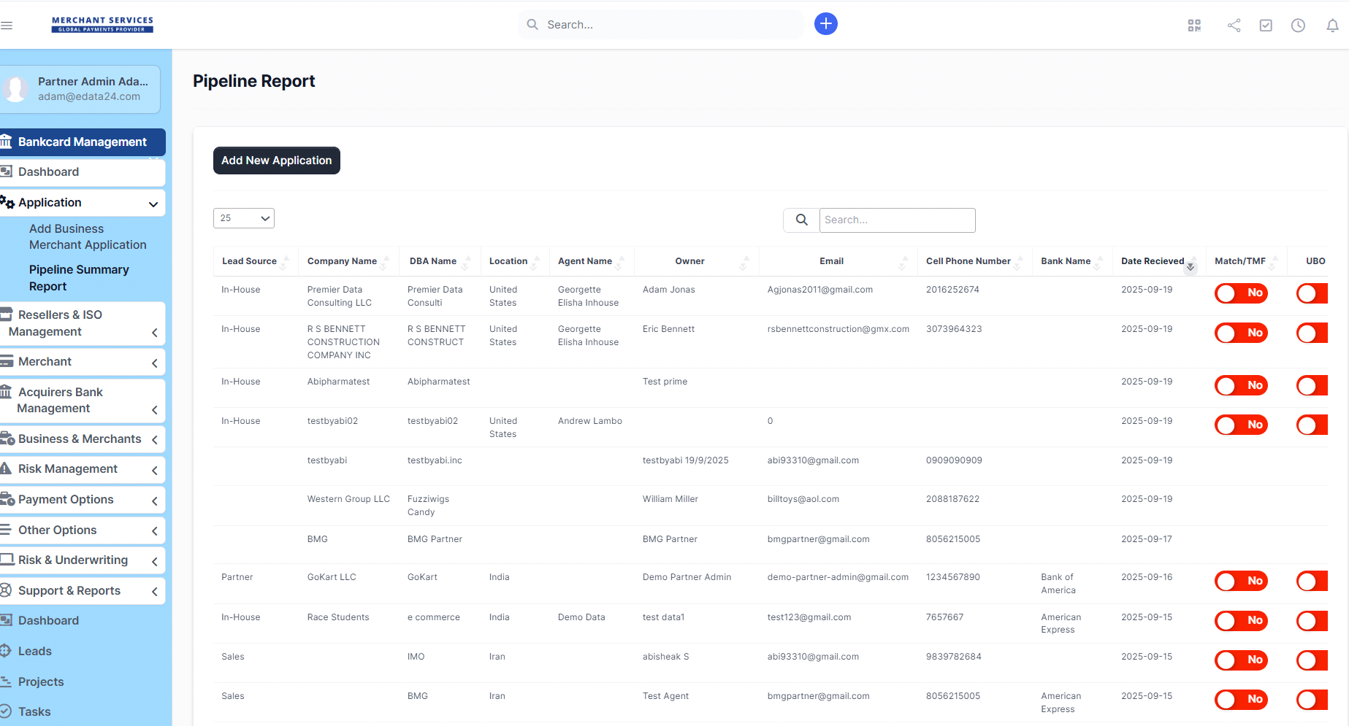
2.
When you are looking fpr mcc code , we sould be able to type the business type to get the mcc code or nerowing te options Done

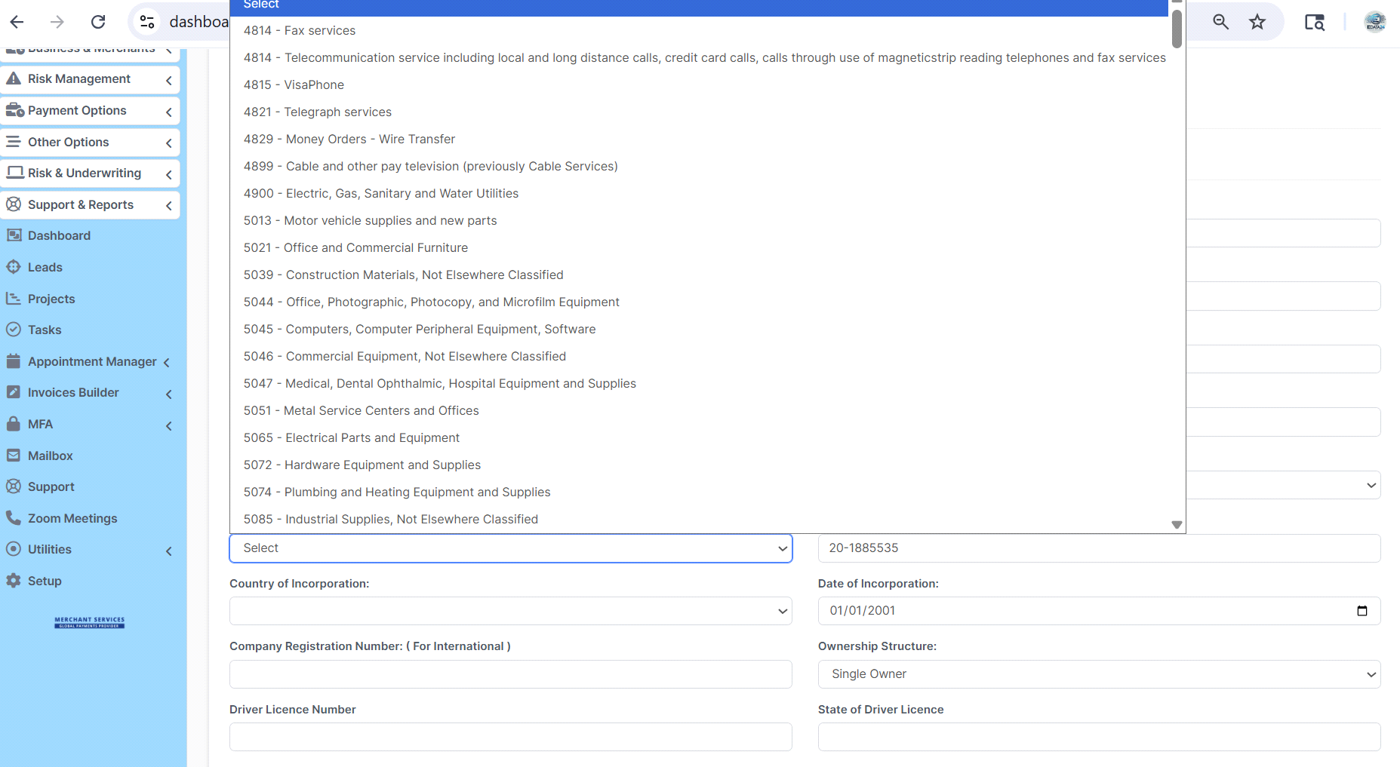
3.
Admin can and should be able to move an app to cancelled, and archive it …
we may have too many app that can be canceled and add the reason for cancelation ( not decline) Done

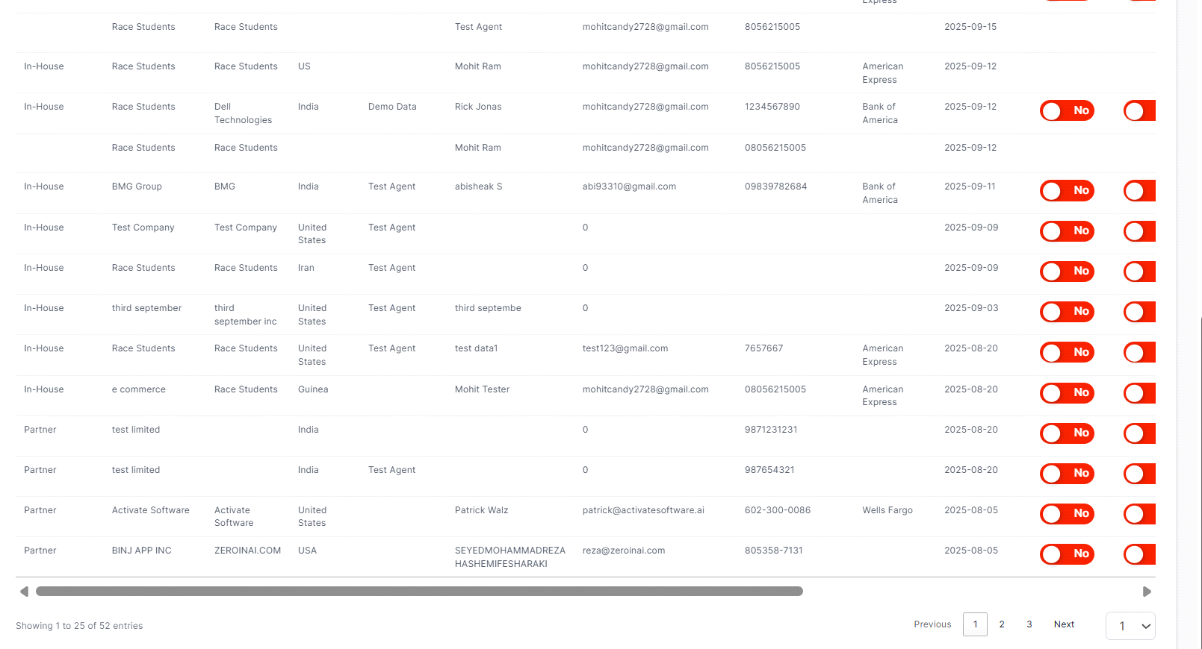
4.
Make sure the Phone number, the ssn and tax id: no spaces Done
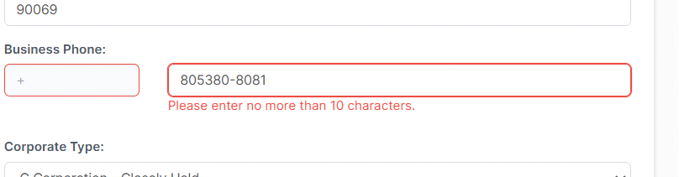
5.
We need to be able to add comments as the underwriter Done
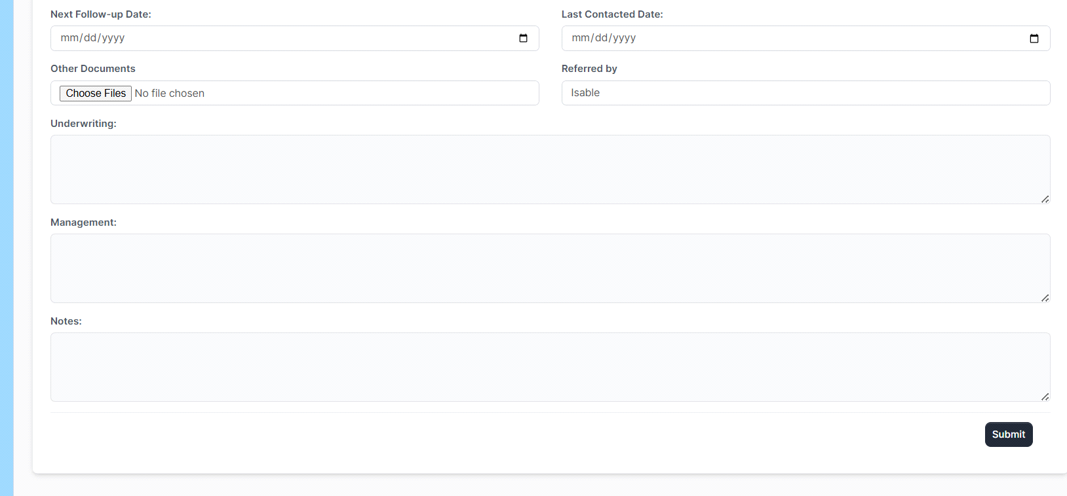
6.
What happened if you have 100 partner agents? Done
Also: the Inhouce needs to be separate: and Assigned to the Inhouse Relation Ship management

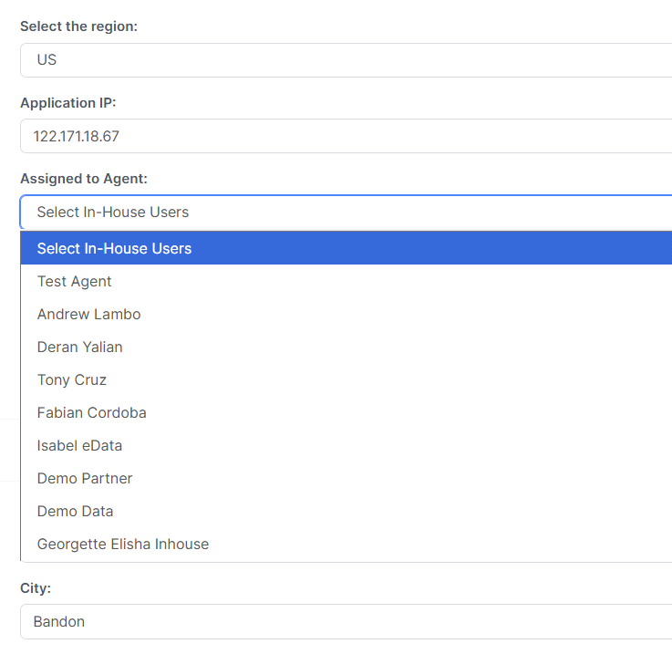7.Where is the Declined option: Done
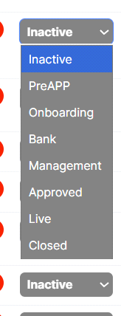

8.Here you need to have : Departments, head of the department , and their name…
Sales
Risk management
Management
Underwriting
Credit Committee
Customer success
Relationship management [

Need to ask Adam
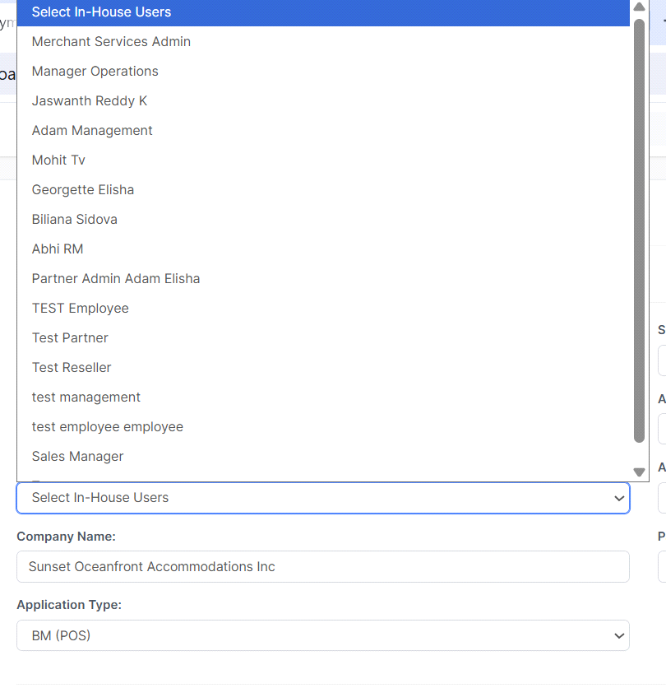
Some are in Management, some: underwriting, some onboarding , some Account executive
Some: Support and so on… I will need the detailed.

10.To make it EZ: make sure you have the US united state on the top of the list Done

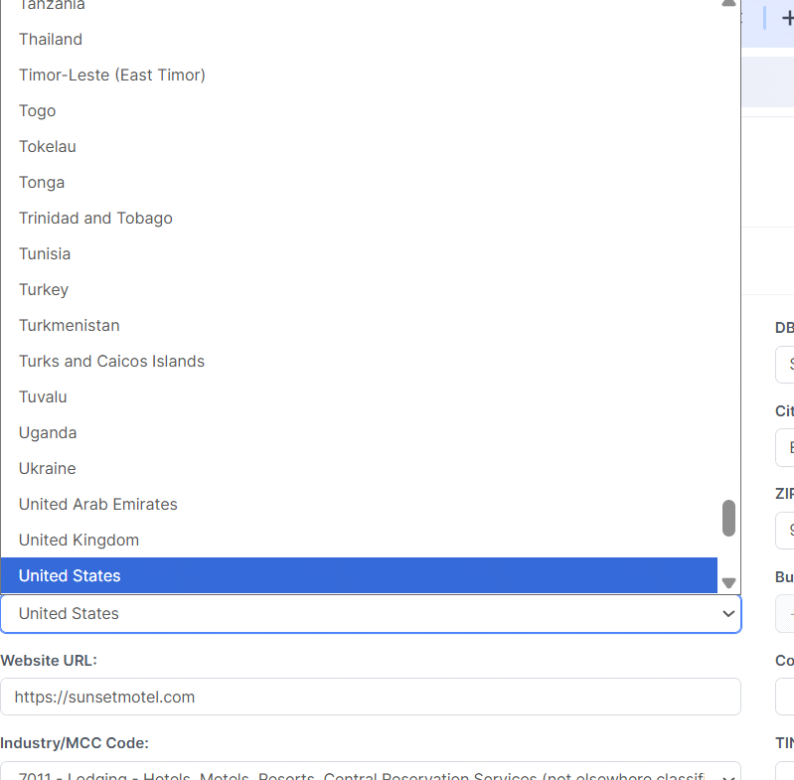
12.Business phone:Done
why we can not add the country code?
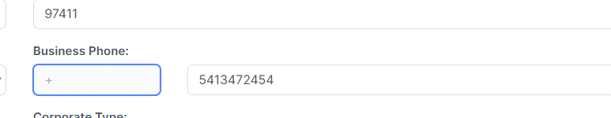

This starting like this after entry but save it incorrectly:

13.Done
Here we have an issue with the phone number : country Code, then Phone number no spaces

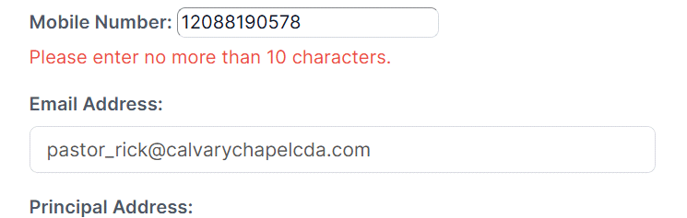
On the personal:
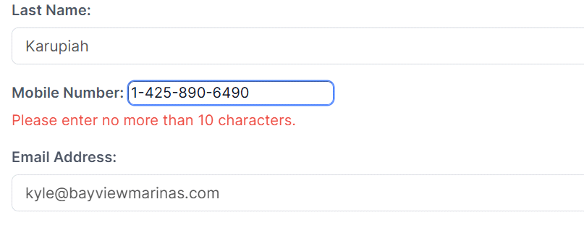
The business:
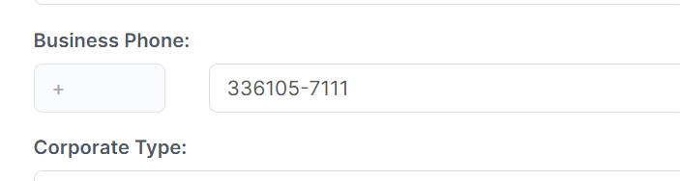
Country cod, the correct Phone number, what if you need a country code, mobile code/city code , then the number…
14.
pastor_rick@calvarychapelcda.com, After I fixed a merchant app :, changed it to live , and fix the Data inside the pipeline app , it did not save it!!!!
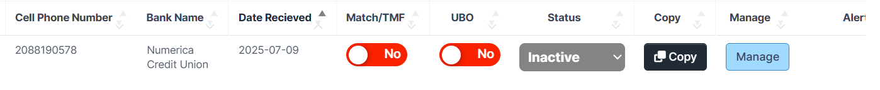
in another word :
Once you go to the Manage: make shanges and click on the submit: it does change the status to inactive … this SHOULD not happen.
If I change on the pipeline, then it stay… FIX it
15. All the data was on the Pre Application we have and gave it to Abi to enter, how come we are missing the information?
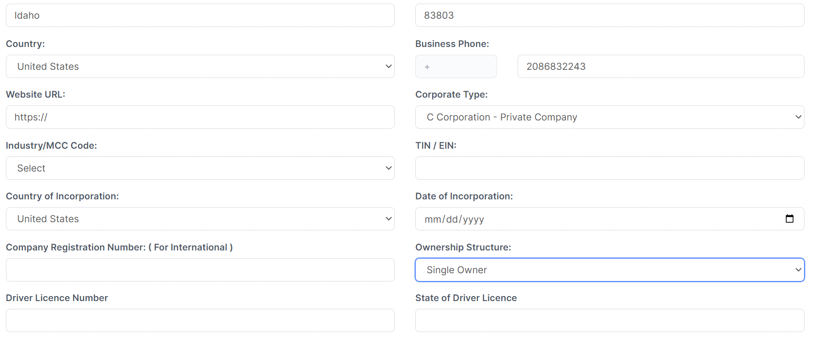
16.
The ISO list and management of the ISO:
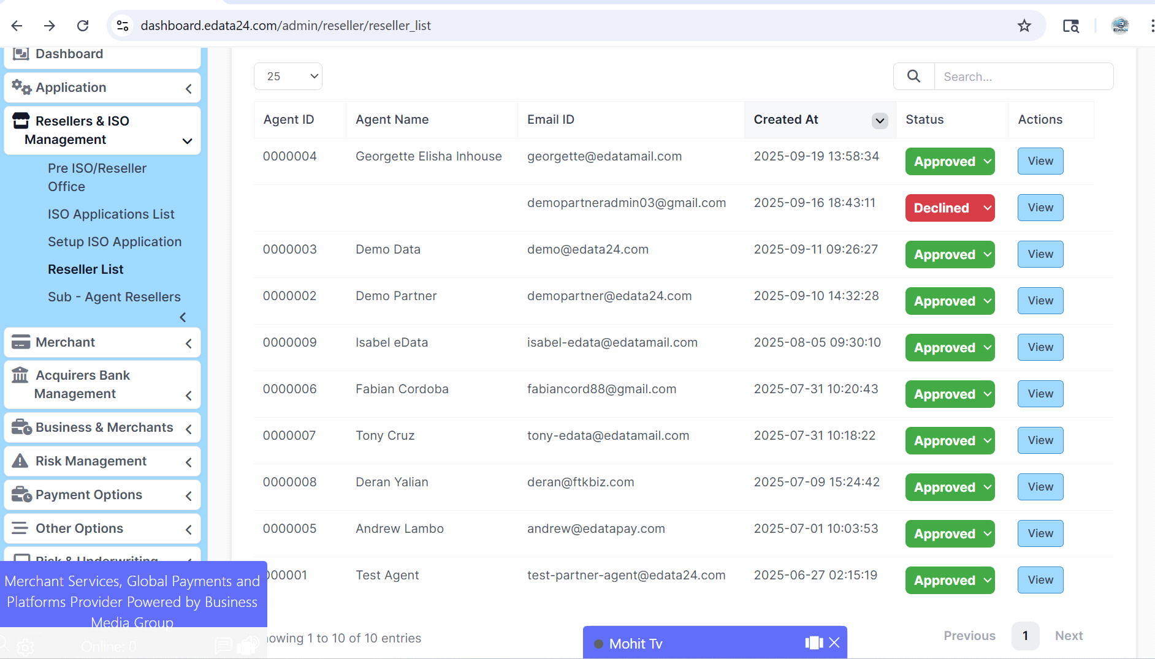
When you click on View , we are losing to page:
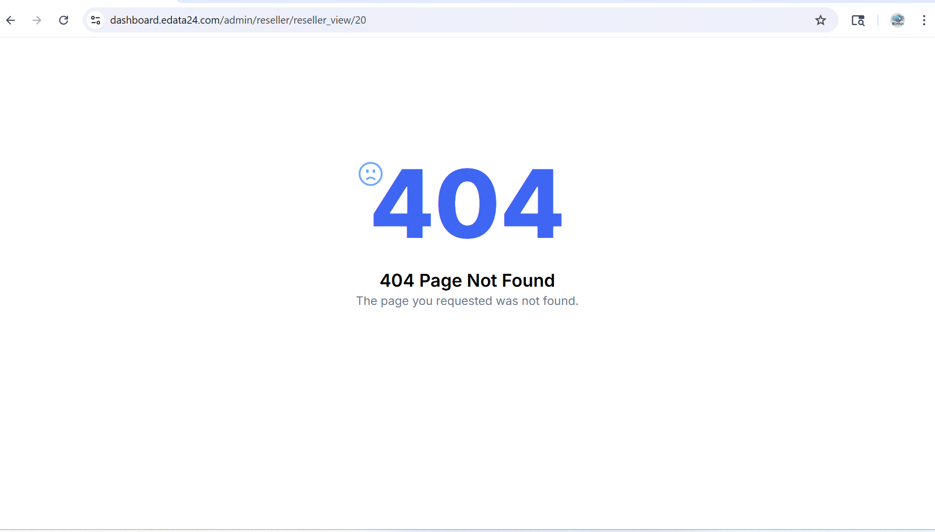
17.You need to add :” On Hold” , to the drop down and the DB.
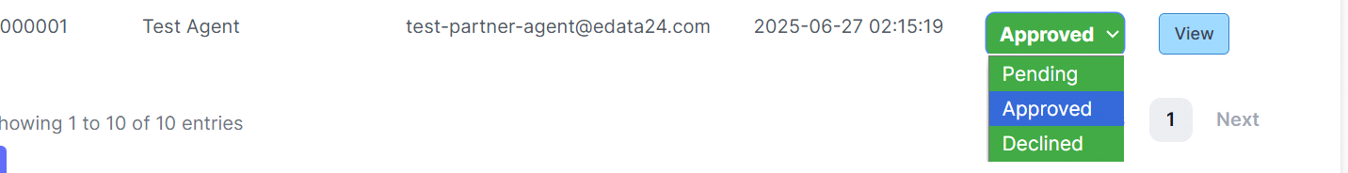
We need to have a place for us to add some Overview on each agent , we need a paragraph we / Admin put some nit information on this Agent.
18.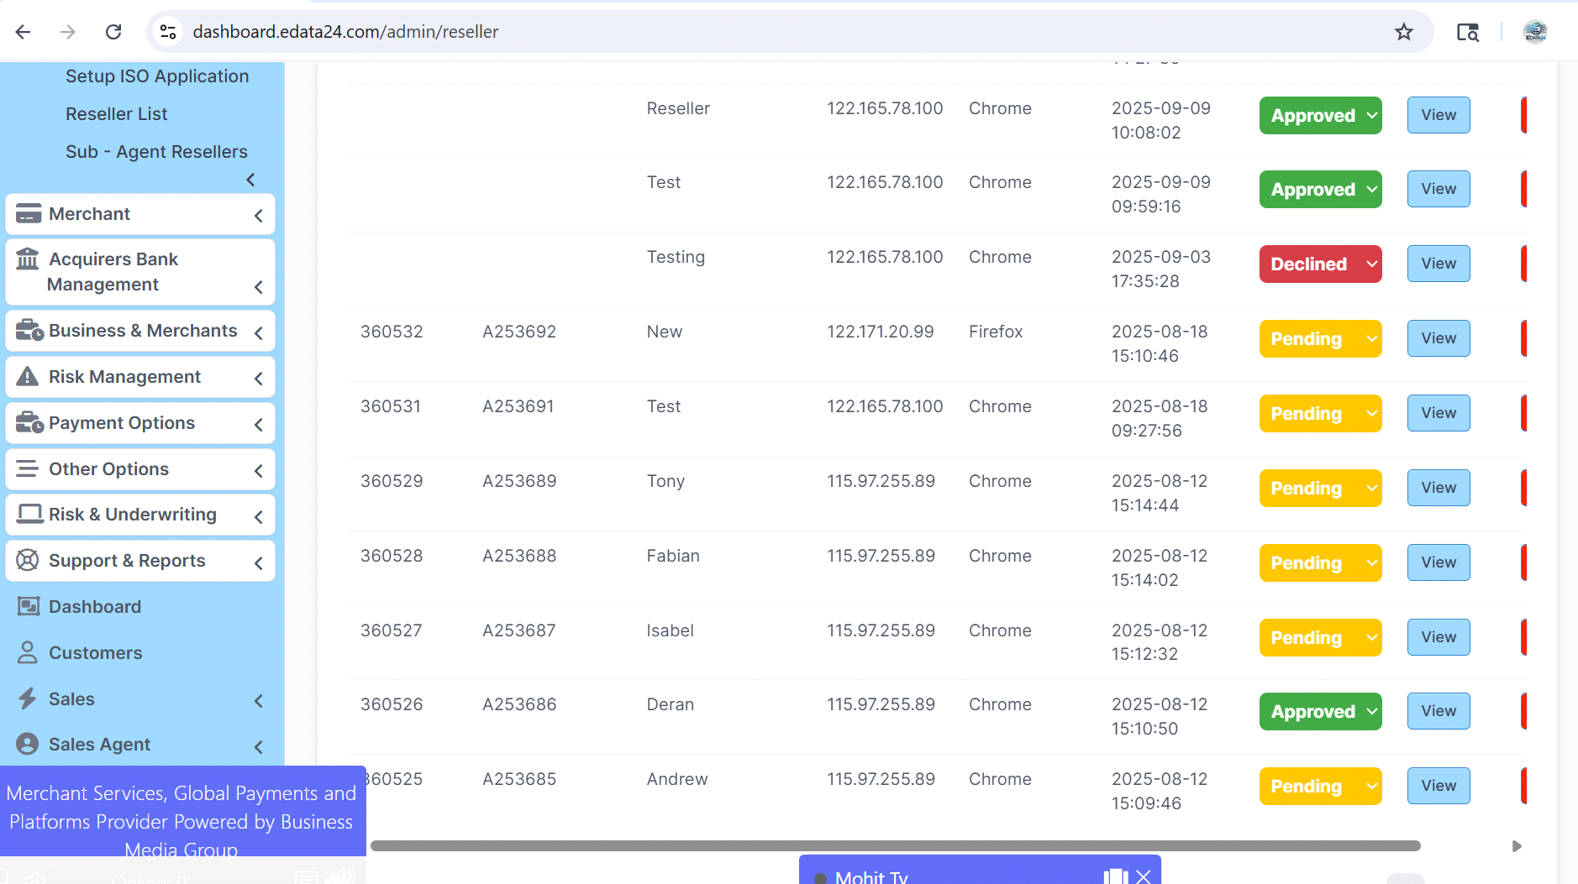
Go view to:
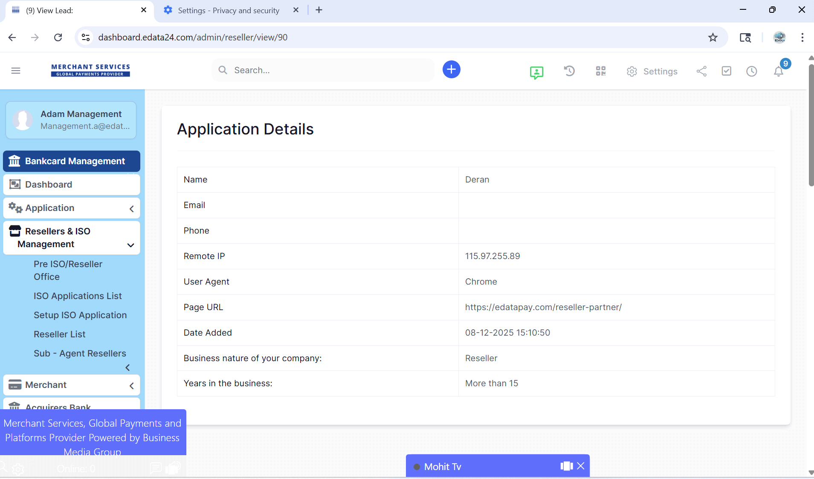

Mohit Points:
Bug List & Execution Plan (19.09.2025)
High Priority
1. Assigned to Agent – Pipeline Report and for Merchant Pre Application List
Issue: Agent assignment missing in report list view.
Plan: Map staff ID to pipeline table → display first & last name → verify across roles.
2. Business Merchant Application – Pipeline Report (Access Control)
Issue: When MST assigns to in-house/ admin, visibility rules fail.
Plan: Update access logic → ensure assigned users see only their applications → role-based QA.
3. Affiliate Link – Agent Name Missing
Issue: If lead comes via affiliate link, agent name is not shown in list.
Plan: Map affiliate referral ID to agent table → show agent name correctly in pipeline → regression test.
Low Priority
4. Duplication Alert
Issue: Functionality not validating properly, duplicates may pass through.
Plan: Re-test current logic → add stricter validation rules → finalize after QA.

Actionable, prioritized TODO for Mohit — Partner CRM Pipeline Report (fix ASAP)
Below is a focused, developer-ready checklist grouped by priority with concrete reproduction steps, suggested CodeIgniter/PHP fixes, SQL hints and acceptance criteria. I also included front-end notes where applicable. I pulled the requirements and notes from your doc.

Critical / High Priority — Must fix first
These directly break the pipeline report, login flow, or cause invalid responses.
1) Agent assignment missing in Pipeline & Pre-Application lists
Symptoms: Agent name not shown in pipeline rows or merchant pre-application lists (including affiliate-sourced leads).
Reproduce: Open pipeline list with sample apps that have staffid / affiliate_referral_id. Confirm blank agent column.
Root cause (likely): pipeline listing query does not join agents/staff table for some rows (ISO/affiliate paths), or uses wrong column (e.g. agent_id vs staff_id).
Fix (PHP/CI):
- Update model query to always left-join the agent table (use LEFT JOIN so rows are shown even if null).
- SELECT p.*, a.first_name, a.last_name, a.agent_code
- FROM pipeline p
- LEFT JOIN agents a ON (p.staff_id = a.id OR p.affiliate_referral_id = a.referral_id)
- WHERE ...
- In controller/view, print fallback: <?= $agent_first_name ? "$agent_first_name $agent_last_name" : ($affiliate_name ?: '—') ?>
- Add a unit of code to map affiliate referral → agent (if affiliate referrals are stored separately, join both tables).
- Add regression tests: create a pipeline row with affiliate_referral_id and confirm name shows.
Acceptance: Every pipeline/pre-application row shows agent name if there is any agent mapping (staff, affiliate), or shows Unassigned otherwise.

2) Invalid JSON returned to DataTables after admin delete
Symptoms: DataTables warning: Invalid JSON response; table blank/JS error after delete.
Reproduce: Delete a record in admin that triggers server-side datatable refresh.
Root causes (common):
- PHP warnings/notices or HTML being output before JSON.
- Controller echoing HTML or redirect and returning non-JSON.
- Missing Content-Type: application/json.
Fix (PHP/CI):
- Inspect server logs and browser response (Network tab). Identify any stray output (warnings, var_dump, BOM).
- Wrap DataTables endpoint with output buffering and JSON encoding:
- $this->output
- ->set_content_type('application/json')
- ->set_output(json_encode($data));
- Ensure delete action returns a JSON success response when invoked via AJAX (not a redirect). Example:
- if ($this->input->is_ajax_request()){
- $result = $this->MyModel->delete($id);
- echo json_encode(['success' => $result]);
- return;
- }
- Turn off debug output on production (display_errors = Off) for endpoints used by DataTables.
Acceptance: After delete, DataTables receives valid JSON and refreshes without client-side error.

3) Logout / Wrong redirect & Forgot Password for Agent
Symptoms: Agent logout redirects to admin logout; wrong forgot-password flow (admin endpoint used for agent).
Reproduce: Login as agent, click logout; attempt forgot-password from agent login page.
Fix (logic & routes):
- Centralize logout in an auth controller that checks session role:
- public function logout(){
- $role = $this->session->userdata('role');
- $this->session->sess_destroy();
- if ($role === 'agent') redirect('agent/login');
- redirect('admin/login');
- }
- For forgot password, provide separate endpoints or a single endpoint that accepts role param and sends correct reset flow:
- auth/forgot_password?role=agent or routes:
- admin/auth/forgot_password
- agent/auth/forgot_password
- Ensure email templates and reset URL include role so agent sees the agent UI.
Acceptance: Agent logout returns to agent login; agent “forgot password” produces a reset email and token usable in agent UI (not admin).

4) Access Control — Agents seeing admin links / actions
Symptoms: Agents can access admin-only pages and actions (delete, edit, settings).
Reproduce: Login as agent, navigate admin pages via URL or UI; check available dropdowns/options.
Fix (both UI + backend enforcement):
- Backend: Add role-check middleware for all admin controllers:
- if ($this->session->userdata('role') !== 'admin') {
- show_error('Unauthorized', 403);
- }
- UI: Hide admin-only menu items based on role in session (view-level).
- Audit critical endpoints (delete, modify, assign-bank) to ensure they also check authorization server-side (not only hidden UI).
Acceptance: Agents cannot access admin pages (403/redirect to agent dashboard). Menu items for agent UI must not show admin links.

Medium Priority
5) Agent ID generation duplicate / sequence not incrementing
Symptoms: New agents get same Agent ID repeatedly (e.g. 000001).
Reproduce: Create multiple agents, observe agent_code/agent_id.
Fix options (choose one, recommended DB-backed):
- Best: Use DB AUTO_INCREMENT or a dedicated sequence table and atomic increment in a transaction. Example (MySQL):
- ALTER TABLE agents MODIFY COLUMN agent_number INT AUTO_INCREMENT;
Or if agent codes must be zero-padded display only: LPAD(agent_number,6,'0').
- If generation is custom:
- Lock the sequence row and increment inside a transaction:
- START TRANSACTION;
- SELECT value FROM sequences WHERE name='agent_id' FOR UPDATE;
- UPDATE sequences SET value = value + 1 WHERE name='agent_id';
- COMMIT;
- Fix save logic to use returned insert ID instead of computing in PHP after insert.
Acceptance: Each new agent gets a unique, incrementing ID. No duplicates under concurrent creation.

6) Duplicate DB inserts (sub-agent reseller saved twice)
Symptoms: Application record saved twice.
Reproduce: Submit sub-agent form, check DB for duplicate rows.
Fix:
- Frontend: disable submit button on form submit and prevent double-click.
- Backend: add unique database constraint on fields that should be unique (e.g. application token or unique application reference).
- Implement transaction handling; if a second insert occurs due to repeat AJAX call, return existing record if unique key violation occurs.
- Add logging to detect where duplicate calls originate (AJAX double request vs server processing loop).
Acceptance: No duplicate rows on double-submit. If duplicate attempt occurs, server returns an error or the existing record id.

7) Phone / SSN / Tax ID formatting & validation
Symptoms: Spaces allowed; inconsistent saving; country code issues.
Fix (frontend + backend):
- Frontend: enforce input masks (no spaces) and show example. Use pattern="\d{10}" for US phone.
- Backend (CodeIgniter Form Validation):
- $this->form_validation->set_rules('phone', 'Phone', 'required|regex_match[/^\d{10}$/]');
- $this->form_validation->set_rules('ssn', 'SSN', 'required|regex_match[/^\d{9}$/]');
- Strip non-digits server-side before saving: $clean = preg_replace('/\D/', '', $input);
- For international numbers, add fields: country_code + phone_local or use E.164 standard.
Acceptance: Phone saved as numeric 10-digit (no spaces) for US; validation fails on incorrect length; UI explains expected format.

Low Priority / UX & Data improvements
8) Application ID for ISO Applications
- Ensure ISO apps get an application ID on creation (same approach as agents: AUTO_INCREMENT or sequence).
- Show Application ID in ISO list view — join and display.
- Decide whether to expose Agent ID (000001) in reseller list; if yes, join agents table and display the approved Agent ID only when status = Approved.
Acceptance: ISO apps always have app ID; shown in ISO list and reseller list for approved ones.

9) “On Hold” status, Cancel reasons, archiving
- Add new enum/status On Hold and Cancelled with reason text field. Update DB status table or enum column.
- Admin UI: allow move → Cancel with required reason; Archive action to hide from default lists but preserve record.
- Add archived_at, cancel_reason columns.
Acceptance: Admin can set On Hold/Cancelled and add reason; default lists exclude archived unless filter chosen.

10) Underwriter comments & admin notes on agents
- Add free-text admin_overview on agents table. Add edit area in admin forms and show in agent profile.
Acceptance: Admins can add/edit a paragraph of notes per agent.

11) MCC search usability
- Replace static dropdown with typeahead (AJAX) to search by business type or code (select2 configured with minimumInputLength).
Acceptance: Typing business type filters MCC list.

12) JS bug: sub-agent reseller / LIFO display
Symptoms: JS error in sub-reseller view causing LIFO issues.
Reproduce: Open sub-reseller page and check console for stack trace.
Fix:
- Open browser console, capture exact error and stack. Likely issues:
- Undefined variable (let x = ... returning undefined)
- DOM query before element exists — wrap in $(document).ready or ensure correct selector.
- Fix code to defensively check arrays/objects before using .pop() or .shift() if LIFO logic used.
Acceptance: No console errors; LIFO ordering works as intended.

Bugs from Mohit’s “Tasks with Logic issues” — summary action items
- Logout redirect (see #3 above) — fix role-aware logout.
- Restrict admin access for agents (see #4 above) — add server-side checks and hide UI links.
- Password mismatch behavior should show agent-only extension — update auth flow to detect role and render proper UI on failed attempts (no redirect to admin login).

Deployment & QA checklist (what Mohit should push/do)
- Implement fixes in a feature branch (name: fix/pipeline-reports-<ticket>).
- Add unit tests where possible (model queries, sequence generator).
- QA steps to run (no time estimates here — just steps):
- Test creating agents concurrently (for sequence).
- Test agent login/logout/forgot-password flows.
- Test DataTables JSON endpoint after deletes.
- Test form double-submit prevention and duplicate insert attempts.
- Verify pipeline list rows show agent names for staff and affiliate sources.
- Confirm phone/SSN validation both client & server.
- Inspect browser console for JS errors (sub-agent pages).
- Code review + merge to staging, then verify on staging before production.

Quick debugging commands & SQL hints for Mohit
- Find missing joins in pipeline: search codebase for FROM pipeline or pipeline model.
- Check for stray output breaking JSON: run grep -R "var_dump\|print_r\|echo '<pre>'" -n in controllers used by DataTables.
- Add unique DB index for dedupe:
- ALTER TABLE applications ADD UNIQUE KEY ux_application_token (application_token);
- Secure sequence increment (MySQL):
- START TRANSACTION;
- SELECT value FROM seq WHERE name='agent_id' FOR UPDATE;
- UPDATE seq SET value = value + 1 WHERE name='agent_id';
- COMMIT;

Communication for Mohit
When you push each fix, include in the PR:
- Files changed + short description.
- Repro steps before and after.
- Which acceptance criteria were satisfied.
- Any DB migration SQL.

